# Objective

## The following document will show case how to configure and work with Jasmine, an open source behavior-driven testing framework for JavaScript. It can run on any JavaScript-enabled platform, to not intrude on the application nor the IDE. Sample code used in the document is focused on testing the java script that resides in a library in SharePoint Online site.

1. Perquisites
2. **Visual Studio 2012** or higher versions

## **Jasmine NuGet Package** (<https://www.nuget.org/packages/jasmine/>). Later in the document its covered how to add the Jasmine NuGet Package through VS.

1. Jasmine Implementation
2. To get started, please create an **empty project** in your Visual Studio.

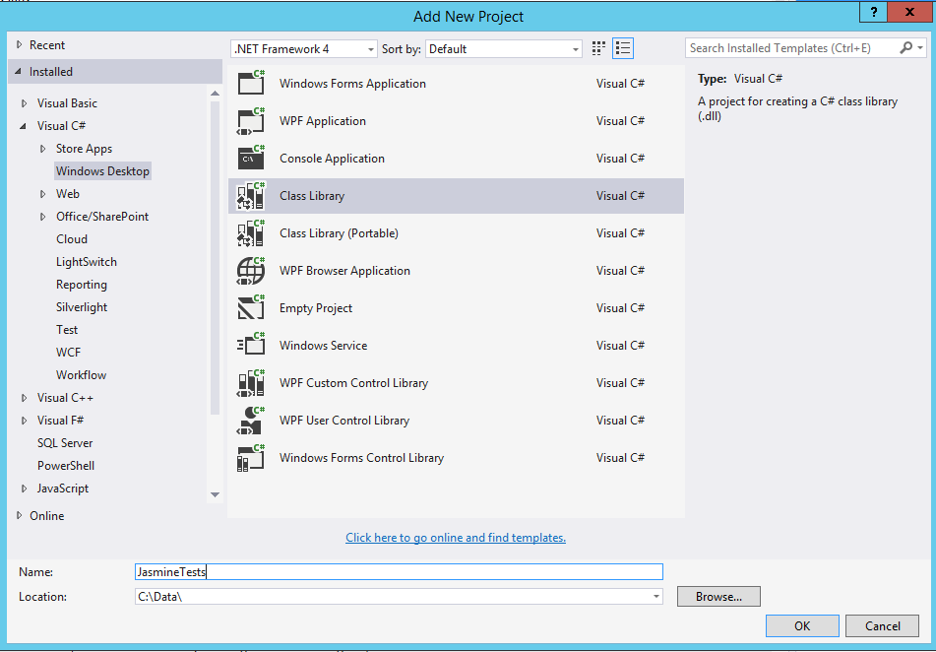

1. Now **install Jasmine** from **NuGet** Package manager. Once you are done, the required files would be added to your project.

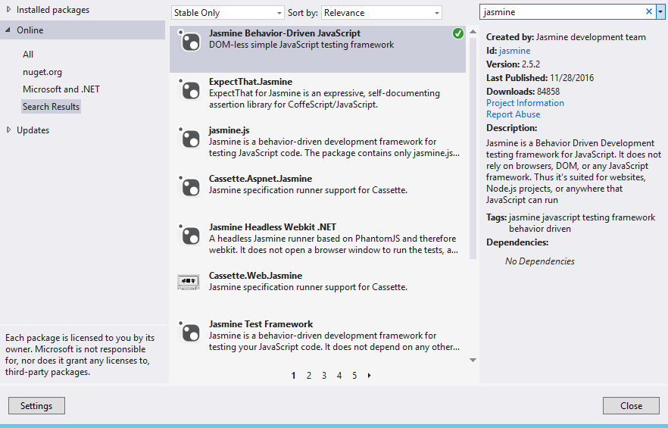

1. Now please add a new **HTML file** on your Jasmine project, this is the page where we can see the test cases in actions, and add all the references as follows. Please do not forget to **include the js files** where we have actually written the validations, jQuery, jQuery (if needed). Here **IndexTests.js** is the file where we are going to write the test cases. (Note: Please refer to the images below for code.)
2. Please go to your **IndexTest.js** file and create a suit and spec as preceding.
3. Now let us go and find whether the test is passed or not. Please run the **SpecRunner.html** page again. In testing framework to avoid alerts, you must create a spy for **window. alert** function and add it to the **beforeEach** so that it can be used for each specs.

|  |
| --- |
|  |

1. Code:

* Jasmine

|  |
| --- |
| 1. SpecRunner.Html |
|  |
|  |
| 1. IndexTest.js |
|  |
| 1. JS File |
|  |
|  |

1. qUnit: QUnit is a powerful, easy-to-use, JavaScript unit testing framework. It's used by the jQuery project to test its code and plugins but is capable of testing any generic JavaScript code (and even capable of testing JavaScript code on the server-side).
2. Jasmine Vs qUnit

* Comparison of Jasmine and qUnit statements
* **qUnit Report**

|  |
| --- |
| image2013-5-23 17-9-56.png |

* **Jasmine Report**

|  |
| --- |
| image2013-5-23 17-10-2.png |

* Jasmine sub packets, and packet is very clear, and qUnit can be tested in a plurality of that number now. This is their advantage; the each has its own merits.
* Comparison of Jasmine and qUnit's assertion

|  |  |
| --- | --- |
| Jasmine | qUnit |
| Jasmine, has 12 original assertion, defined at the same time, we can easily own assertion, this is a big advantage | qUnit comes with 8 kinds of assertions, of course you can expand, but relatively trouble, the only advantage is that can take a custom description |

* From the comparison of the assertions, Jasmine slightly advantage.
* Comparison of Jasmine and qUnit Module

|  |  |
| --- | --- |
| Jasmine | qUnit |
| Jasmine describe () are grouped and module, the advantage is that it can be nested, namely can molecular module is very good, very clear use function. | qUnit module () group, not molecular wood. |

* From the comparison of module, Jasmine has more advantage.
* Comparison of qUnit and Jasmine test method

|  |  |
| --- | --- |
| Jasmine | qUnit |
| Jasmine uses as a performance test method. | qUnit contains 3 methods for testing. The method of asynchronous test, and the expect () can limit the number of claims. |

* From the comparison of method, qUnit has more advantage.
* Tabular Comparison: Jasmine Vs qUnit

|  |  |  |
| --- | --- | --- |
| **S.No.** | **Description/ Method** | **Result** |
|  | ‘Grouping’ method | Jasmine > qUnit |
|  | ‘Test’ method | Jasmine ≈ qUnit |
| 3. | Asynchronous Control | Jasmine < qUnit |
| 4. | Mock and Spies (Providing mock and spies are good functions for unit test.) | Jasmine > qUnit |
| 5. | Test Report | Jasmine ≈ qUnit |
| 6. | Integrate VS | Jasmine ≈ qUnit |
| 7. | Integrate CI | Jasmine ≈ qUnit |
| 8. | Parameterized tests | Jasmine <qUnit |
| 9. | Configuration with Require.Js | Jasmine ≈ qUnit |
| 10. | Setup and Teardown | Jasmine ≈ qUnit |